A

Seminar Report

On

EYE OS



Under the supervision of

SUBMITTED TO: SUBMITTED BY:

Himanshu Sharma

R.NO. – 1710025

MCA 4thSem

**TILAK RAJ CHADHA INSTITUTE OF MANAGEMENT AND**

**TECHNOLOGY, YAMUNA NAGAR-135001**

**Affiliated to Kurukshetra University, Kurukshetra**

**(Approved by AICTE, New Delhi)**

**INDEX**

1. **INTRODUCTION**
2. **HISTORY**
3. **ARCHITECTURE OVERVIEW**
4. **FEATURES**
5. **SECURITY**
6. **WHAT IS A PROCESS IN EYE OS?**
7. **MARKET VIEW**
8. **ADVANTAGES**
9. **DISADVANTAGES**
10. **APPLICATION DOMAIN**
11. **FUTURE SCOPE**
12. **CONCLUSION**
13. **REFERENCES**
14. **INTRODUCTION**

There are a number of online operating systems available today, and the number is steadily growing. EyeOS is a web-based open source platform designed to hold a wide variety of web applications over it. It looks like a regular PC operating system, but the "trick" is that it can be accessed from anywhere. If you travel all the time, or you don't own a PC or laptop or move often, then you can access EyeOS from an Internet Cafe.  
All you need is a web browser, Internet access and EyeOS is there for you, always, all the time. EyeOS is one of the few that is not only provided for free as a service complete with online storage, but is also open source under AGPL3, so you can install it on your own server.  
EyeOS is built on PHP and uses a combination of web standard technologies such as HTML, JavaScript and CSS to create the UI. This means that it will run on any standards compliant browser. By itself, it doesn?t require any extra plug-in in order to work. All it needs is a PHP 5 capable server, which is the common denominator for just about any hosting package ? it doesn?t even require a database.  
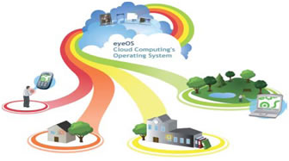  
*Fig 1: Centering work and entertainment in a single place*  
EyeOS is all about entering work and entertainment in a single place. EyeOS is about removing compatibility issues between applications and operating systems and taking your life everywhere. EyeOS is available in 30 translations. And is used privatively and professionally throughout the world rather it is used for public environments, schools, small and large companies alike or a way to share data with your family. EyeOS has a use in our digital life era.

1. **HISTORY**

Establishment: In 2005, a group of young people worked together and put all their efforts in a new project, a new open source web desktop, **EyeOS**.  
August 1, 2005: The first publicly available **EyeOS** version was released as **EyeOS** 0.6.0. At the time, it greatly participated in creating the definition of a web operating system and acted as a concept. Quickly, a worldwide community of developers took part in the project and helped improve it by translating, testing and developing it.  
June 4, 2007: After two years of development, the **EyeOS** Team published **EyeOS** 1.0. Compared with previous versions, **EyeOS** 1.0 introduced a complete reorganization of the code and some new web technologies, like eyeSoft, a portage-based web software installation system.   
July 2, 2007: With the release of the 1.1 version, **EyeOS** changed its license and migrated from GNU GPL Version 2 to Version 3.  
October 29, 2007: 1.2 version was launched with full integration compatibility with Microsoft Word files.  
January 15, 2008: **EyeOS** 1.5 Gala was liberated. The first version that supported both Microsoft Office and OpenOffice.org file formats for documents, presentations and spreadsheets. It also had the ability to import and export documents in both formats using server side scripting.  
April 25, 2008: **EyeOS** 1.6 included many improvements such as synchronization with local computers, drag and drop, a mobile version and more.  
January 7, 2009: **EyeOS** 1.8 Lars featured a completely rewritten file manager and a new sound API to develop media rich applications.  
April 1, 2009: 1.8.5 version incorporated a new default theme and some rewritten apps like the Word Processor and the Address Book.

**3. ARCHITECTURE OVERVIEW**

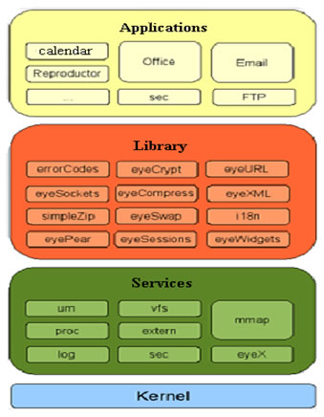  
*Fig 2 Architecture overview*  
EyeOS kernel uses a structure divided into 4 layers:

* Kernel: unified system services.
* Services: lower-level functions.
* library services: higher-level functions
* Applications: can call functions from any? layer
  1. **What is a process inside eyeOS?**

Every time an application is executed, an entry in the process table of a user is created. This entry is an associative array that contains information about the name, Process ID (pid) , currentUser (the name of the user who launched the process) and the time it was launched. In the default installation, the process table is a session variable named 'ProcessTable'. By default, an EyeOS application can have multiple instances of itself running flawlessly. Every instance has its own entry on the Process Table and has its own information separately from the others. Despite that behaviour, a programmer can make an application to avoid having multiple instances by looking up the name of the application in the process table.

**5. SECURITY**

This service stands out primarily for its tight security, which has earned an average growth of 400 users per day. Some of its security measures involve the use of firewalls, backups every 24 hours total, and formatting a month as a preventive measure in case some are infiltrated by malicious code. As additional precaution, all communication is made within the site, and all content stored by users is fully encrypted and no access by their administrators, which gives an additional advantage in terms of use privacy.

**6. FEATURES**

* Being able to work from everywhere, regardless of whether or not you are using a full-featured, modern computer, a mobile gadget, or a completely obsolete PC.
* Sharing resources easily between different work centres at company, or working from different places and countries on the same projects.
* Always enjoying the same applications with the same open formats, and forgetting the usual compatibility problems between office suites and traditional operating systems.
* Being able to continue working if you have to leave your local computer or if it just crashes, without losing data or time: Just log in to your EyeOS from another place and continue working.
* A Web OS runs on any Internet enabled computer or device. This is important for mobile workers or people who don?t have their own computers and must work out of Internet cafes, libraries, or schools.
* Web OS users can work, log out, and then log in later from a different computer.
* Web OS can run on different computers, the technology facilitates collaboration among multiple work centres. The traditional OS runs on only one computer.
* Extensions such as the Network File System a way for different machines to import and export local files and remote desktop a way to control one computer by using another device allow easier access to information from multiple locations and better user collaboration.
* With a Web OS, users can store, find, and otherwise manage files and services, such as calendars and email, from a Web desktop.
* Storing applications, files, and services on an OS provider?s servers, rather than on the user?s computer, make them harder for a PC or laptop thief to use.
* Web OS users don?t have to back up or archive work because the provider?s remote server handles these functions.
* The technology also promises to reduce users? long-term computer and device costs because much of the heavy processing is concentrated in providers? remote servers, Sun?s Web OS operates across platforms, it eliminates compatibility issues between applications and operating systems. Thus, the same Web OS will run on a Windows, Mac, or Linux machine.
* Application developers create an application only once for a Web OS, rather than many times for each of the traditional operating systems. And system administrators have to deploy an application only once for a given Web OS.
* They can then easily distribute it online to users. Because the Web OS and its applications are generally based in servers that can be monitored and secured from one location, they provide centralized malware protection.

**7. MARKET VIEW**

The idea behind EyeOS is that the whole system lives in the web browser. The client must have only a web browser to work with EyeOS and all its applications, including Office and PIM ones. This applies to for both modern and obsolete PC?s.?  
There are no license costs with EyeOS: Its Free, Open Source Software. Special programming, Support & Maintenance up to 24x7, Training and adaptation are offered as professional services. EyeOS work with private and public companies that are looking for an internal intranet: big companies that would like to offer a virtual desktop to their customers, small and big administrations, and the education world EyeOS for Education.   
Free Internet Access Points Resources Management Internet & Access Providers Servers Management EyeOS Mobile Professional Meetings Manager Available Services. These are the projects that have under consideration and working effectively by keeping in mind to give the best cloud service. The free public server for everyone that has already reached 4,00,000 users.  
EyeOS provides Support Packs for both Open Source and Commercial Edition customers. Whether you are trying EyeOS for the first time or deploying a mission-critical application, we have a plan that meets your needs and budget.  
Who would like to have a full EyeOS environment with more space, more allowed upload max file size, the ability of managing users and groups and installing new applications there hasn?t been an officially offered option before.  
We’re today starting tooffer full EyeOS servers, with the following specs:

* From 5 GB to 40 GBof space
* Unlimited number of users
* EyeOS bundled with everything necessary to run inside. The specs and configurations have been prepared by the EyeOS Team.
* Office support enabled and working from the first moment. There is a separatedserver (outside the EyeOS servers) only for Office, so the office files conversion is specially fast even in the smallest servers, since it?s done in a much more powerful server inside the network.
* A maximum upload file sized of 1000 MB (you can basically upload almost every file you want to your EyeOS and keep it online, directly with eyeUpload or through eyeSync for Windows, Mac and Linux).
* Every single server is inside a Virtualized Private Server environment: Your data will be safe and protected against others access.
* You will have the root account inside your EyeOS Server: This means being able to install new applications, creating work groups, enabling or disabling the possibility to allow people to create accounts, assigning a maximum space quota per every user.

**8. ADVANTAGES**

* Portability,
* Decentralization,
* Availability.

**9. DISADVANTAGES**

* Safety,
* Need for fast connection performance,

**10. APPLICATION DOMAIN**   
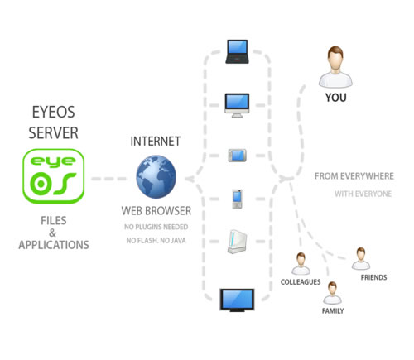  
*fig 4.1 Application domains*

* EyeOS provides system for the users where they work with EyeOS and all its applications, including Office and PIM ones. EyeOS provides a toolkit to create new applications easily.
* EyeOS can provide schools and universities with a full web platform where students, teachers and parents will have a personal yet collaborative desktop to work and, communicate between themselves and get organized inside and outside the school.
* With a private server, EyeOS can provide city councils, public library networks, free Internet points and other public environments the perfect system for their users to have a web place to work and communicate with the network managers, registering once and using it from every point.
* One of the main triggers and great acceptance of people with regard to this service is its availability online, which has no dependencies and has a strong security system, achieving thus be an ideal application for storing content. This action may be useful for those who travel frequently, for schools that want a centralized storage and available for intranets and business in general and so on.; Even could be used in any future as a service to replace the need for a hard disk

**Among the most typical uses are highlighted**

* Schools: There is a Web system that brings a personal space for each teacher and student, which can be leveraged to work collaboratively. Also it is best accessed from anywhere you have Internet access.
* Public places may be in libraries or on points that have open WiFi, allowing users to connect to have the same meeting place on the Web. Social Organizations and Companies: Contacts, personal files and communications to which members can access businesses and organizations large and small.

**11. FUTURE SCOPE**

**EyeOS 2.0 for developers**

EyeOS 2.0 is a development framework for creating RIAs quickly and easily. It has been fully developed using open technology and widely accepted standards, such as PHP, MySQL, javascript, qooxdoo, log4php, phpunit, OpenOffice and others, allowing the system to work on a common web server without any modification, and any standard browser, without needing to install additional plugins.  
EyeOS 2.0 is much faster than EyeOS 1.x, since it gives much more prominence to JavaScript. We have completely eliminated the PHP code which is not used for business logic. As a result, the client needs to make fewer requests to the server, and makes them only when needs persistence of data or specific business logic.  
 EyeOS 2.0 has also added a cache system on the client side to eliminate server requests, even when these are for data persistence. The logical architecture of the system remains very similar to EyeOS 1.x, however, everything has been rewritten from scratch using design patterns with object-oriented programming, where for example, each system service kernel singleton component.

**12. CONCLUSION**

* is designed for developers without experience to develop web applications.
* communication with the user through events.
* Creation of the interface using widgets.
* Advantages: Portability, decentralization, availability.
* Disadvantages: safety, need for fast connection performance, isolation of the host system.
* Worldwide availability: As it?s available through internet
* Requires only browser: A browser with java support is more than enough
* ?Dynamic content and design: Interface can be customized according your needs, windows are floating so that they can be repositioned
* Extensive list applications: Office applications, multimedia applications, network applications and chat applications etc. are available.
* Remote storage facility:? Through the file browser you can store files over the internet and edit them as you want.
* Browser and Platform independent: All browsers and all operating systems are supported.
* Rich text editing facility

**13. REFERENCES**

* [**https://www.opensourcecms.com/eyeos/**](https://www.opensourcecms.com/eyeos/)
* [**https://www.softaculous.com/apps/projectman/eyeOS**](https://www.softaculous.com/apps/projectman/eyeOS)
* [**https://en.wikipedia.org/wiki/EyeOS**](https://en.wikipedia.org/wiki/EyeOS)